
School of Computing | Diploma in Information Technology
ST0280 Cloud and Service Development
Continuous Assessment 1
Done by:
Zachary Tan Chien Loong (p1829176)
Lee Wei Xian(p1828878)

LINK TO GITHUB REPO

Task1

Web-API Documentation:

1. Get weather service

METHOD | GET
ROUTE | https://api.data.gov.sg/v1/environment/2-hour-weather-forecast
OPTIONAL PARAMETERS | date_time: String  date: String
EXAMPLE
RESPONSE | 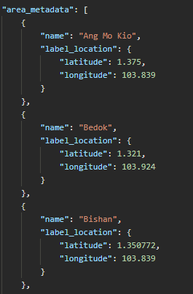

Sequence Diagram:
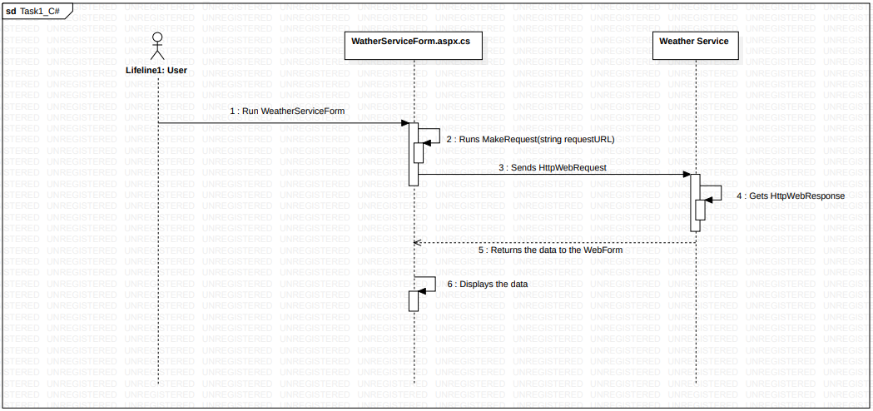
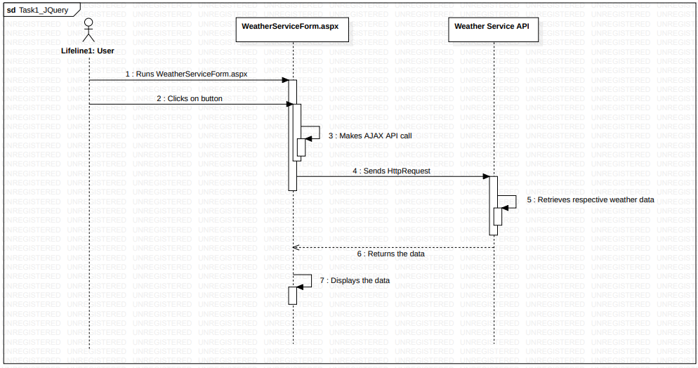

Task2

Web-Api Documentation:

1. Get all products

METHOD | GET
ROUTE | /api/v3/products
EXAMPLE | 
RESPONSE | 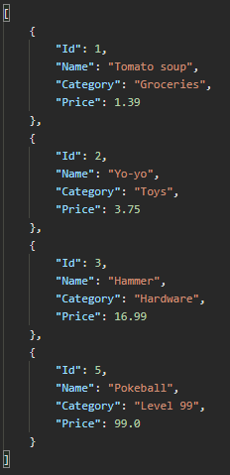

2. Get product by id

METHOD | GET
ROUTE | /api/v3/products/{id:INT:min(1)}
EXAMPLE | 
RESPONSE | 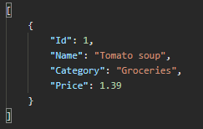

3. Get product by category

METHOD | GET
ROUTE | /api/v3/products?category={categoryName}
EXAMPLE | 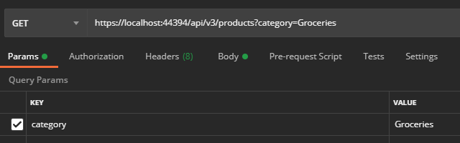
RESPONSE

4. Create new product

METHOD | POST
ROUTE | /api/v3/products
EXAMPLE | 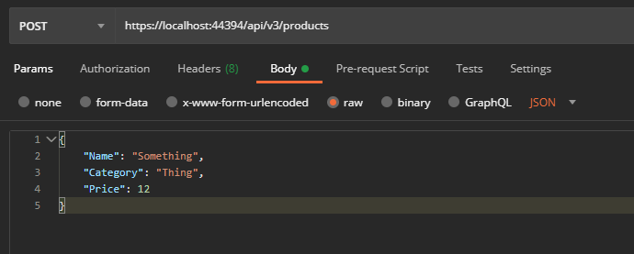
RESPONSE | 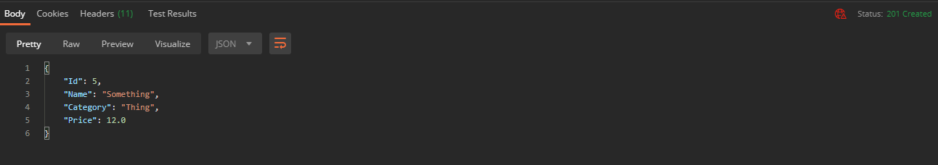

5. Update product by id

METHOD | PUT
ROUTE | /api/v3/products/{id:INT}
EXAMPLE | 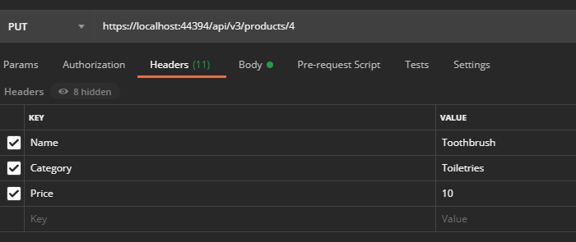

6. Delete product

METHOD | DELETE
ROUTE | /api/v3/products/{id:INT}
EXAMPLE

Screenshots:
Under-posting: Situation whereby the client leaves out some properties when sending request(s) to the controller.
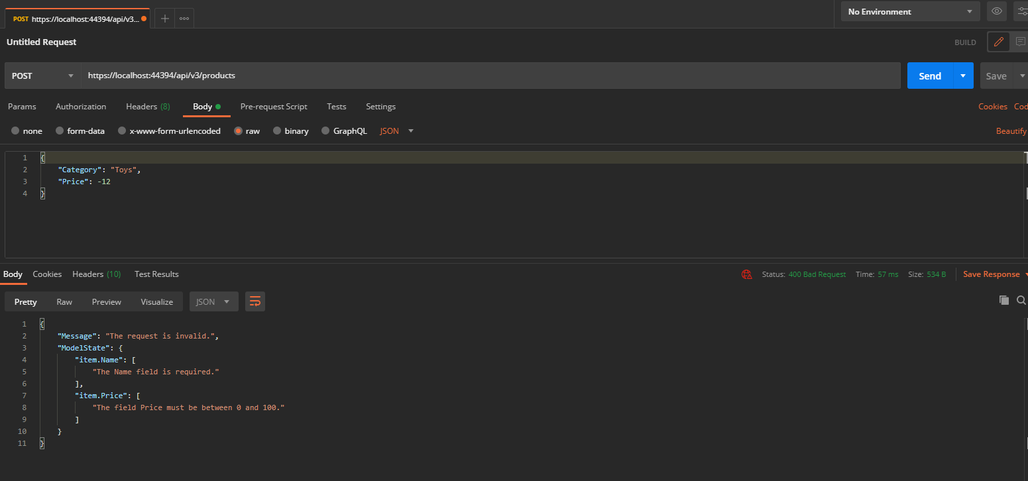
[This happens when there is a case of under-posting]

Over-posting: Situation whereby the client sends more data than expected to the controller.
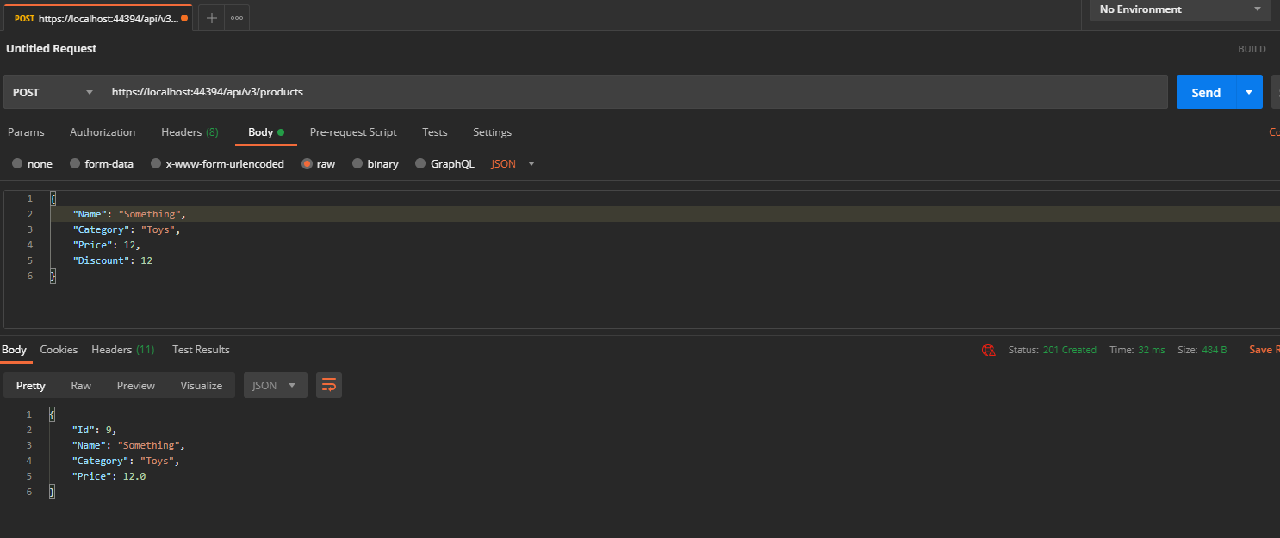
[This happens when there is a case of over-posting]

Task3

Web-Api Documentation:

1. Register an account

METHOD | POST
ROUTE | /api/Account/Register
PARAMETERS  REQUIRED | email: String, password: String, confirmPassword: String, reCaptcha Site-Key: String

2. Login to an account

METHOD | POST
ROUTE | /api/Token
PARAMETERS  REQUIRED | username: String, password: String, ‘password’: grant_type

3. Logout of an account

METHOD | POST
ROUTE | /api/Account/Logout

4. Get Values(Authorization)

METHOD | GET
ROUTE | /api/values

Sequence Diagram: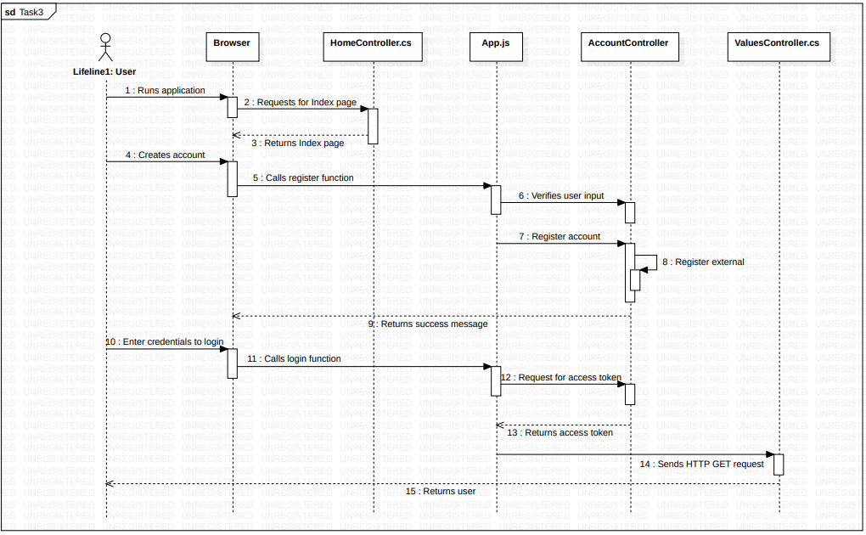

Screenshots:
Register Successful:
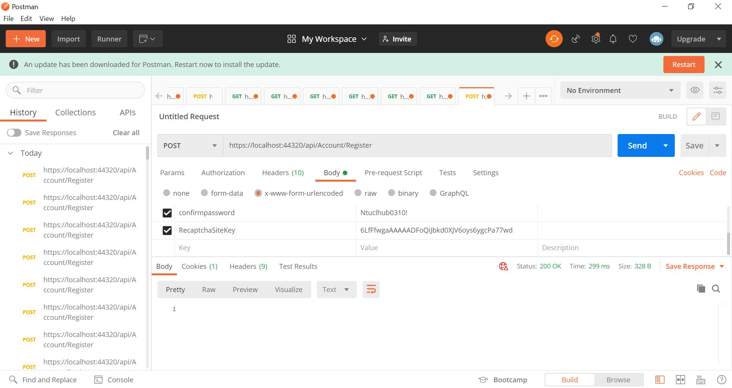

Register(email invalid!):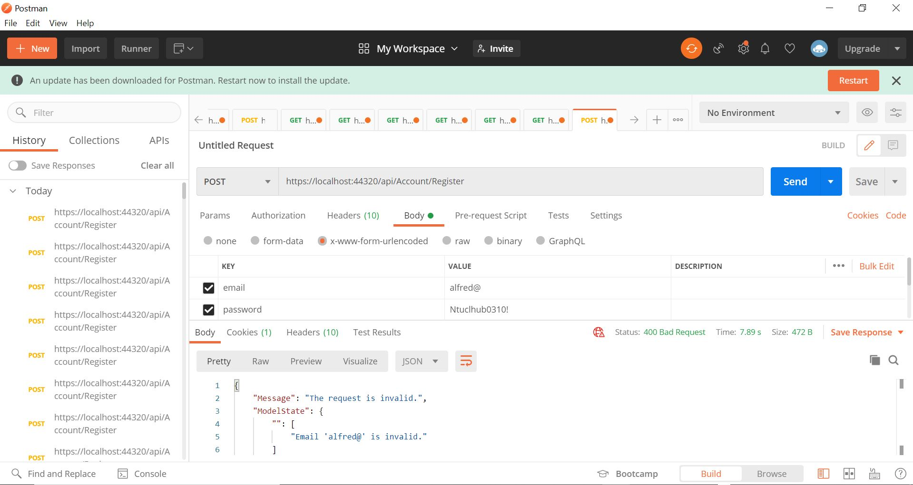

Register(password invalid):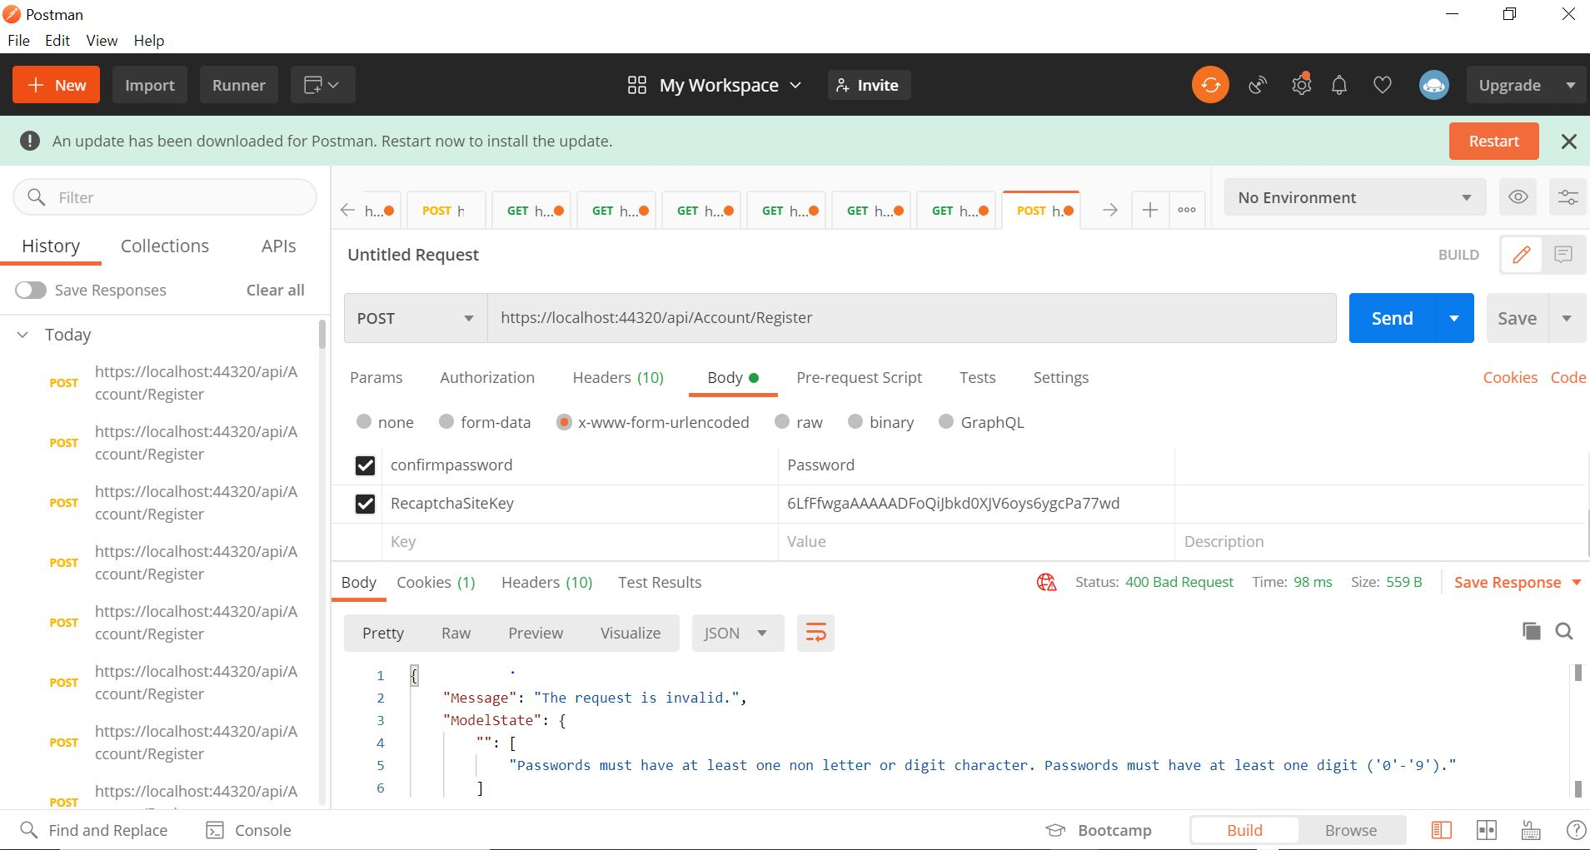
Register(password do not match):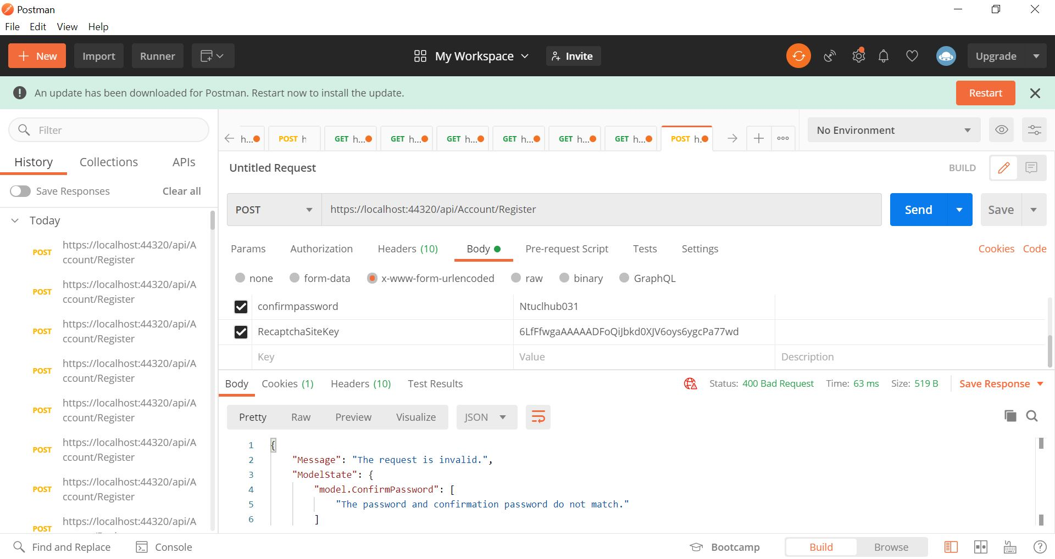

Login(Successful):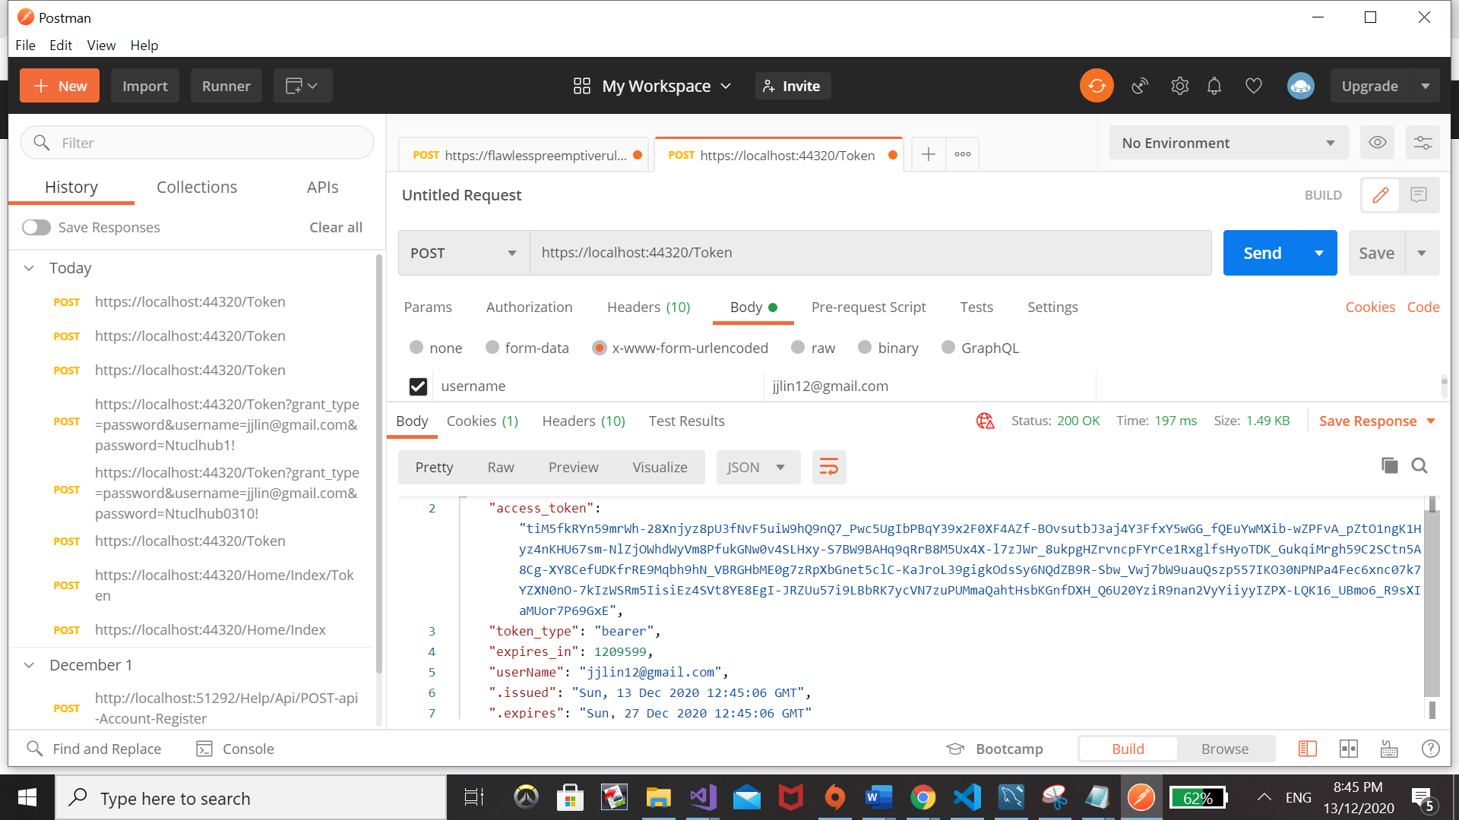

Login Unsuccessful:
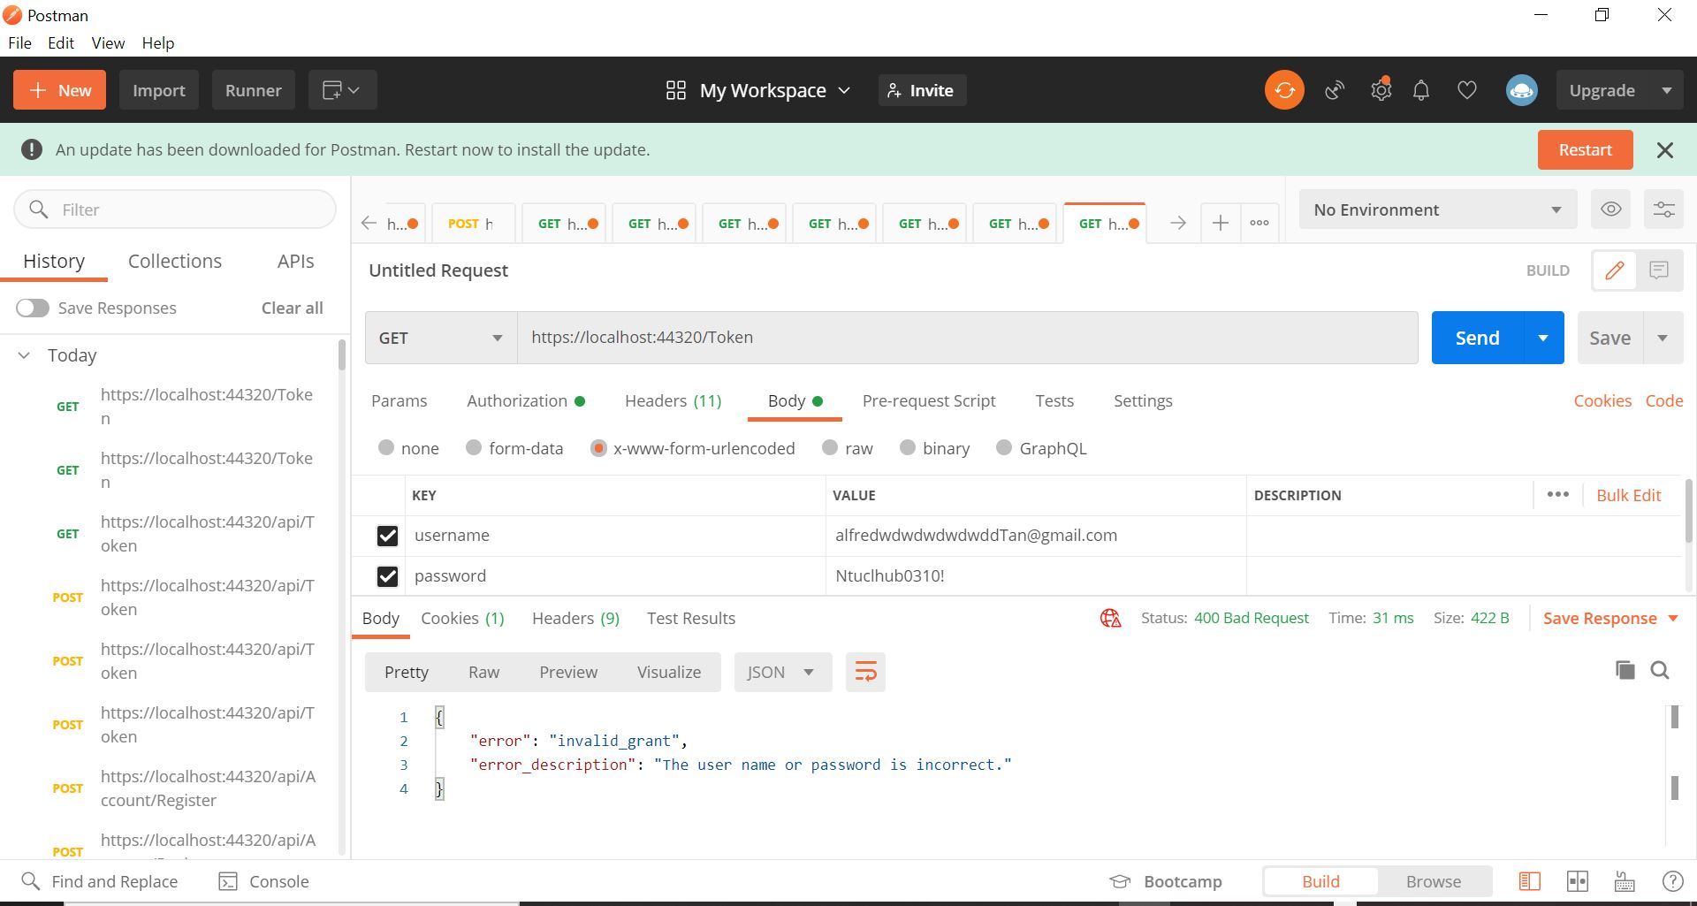

GetValues(Successful):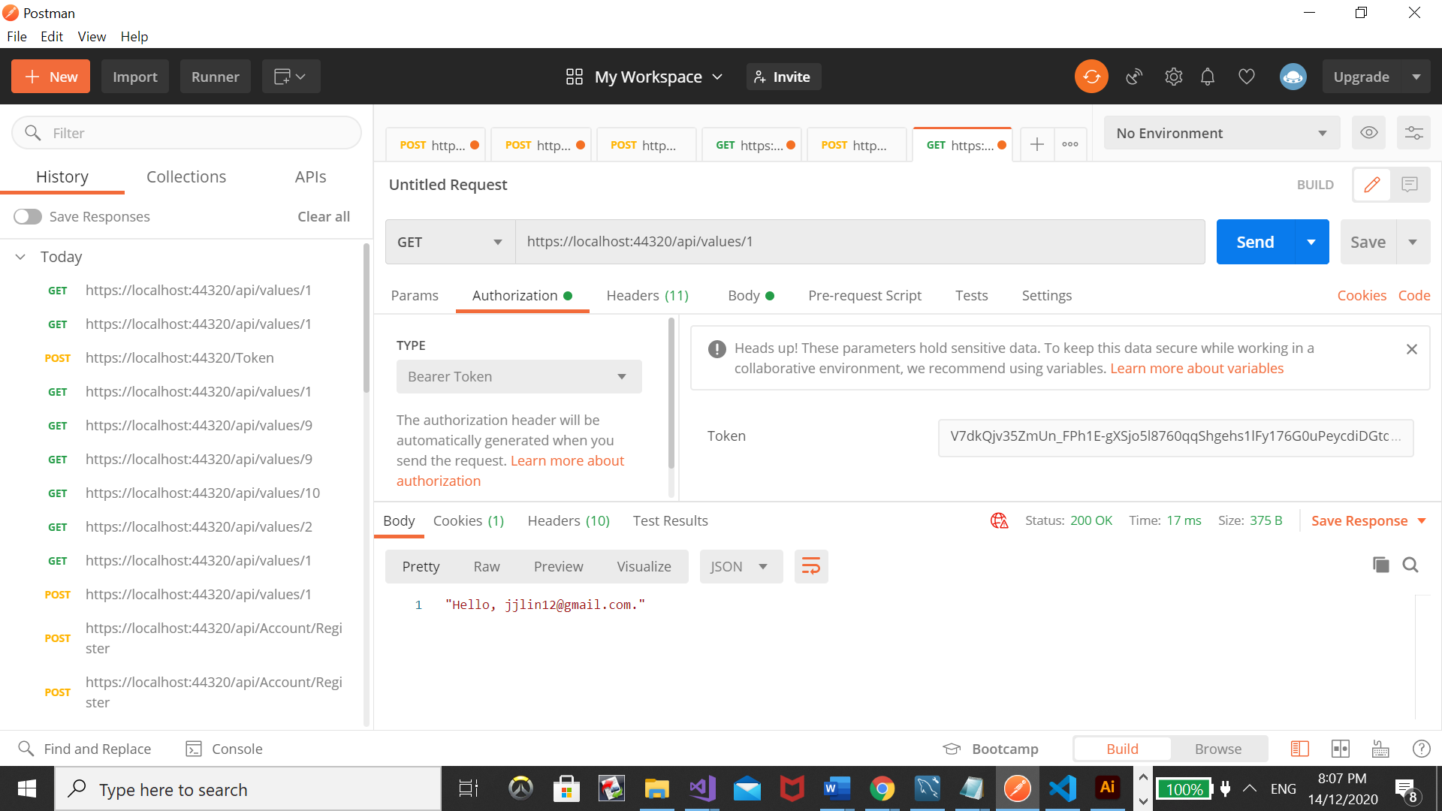

Unsuccessful: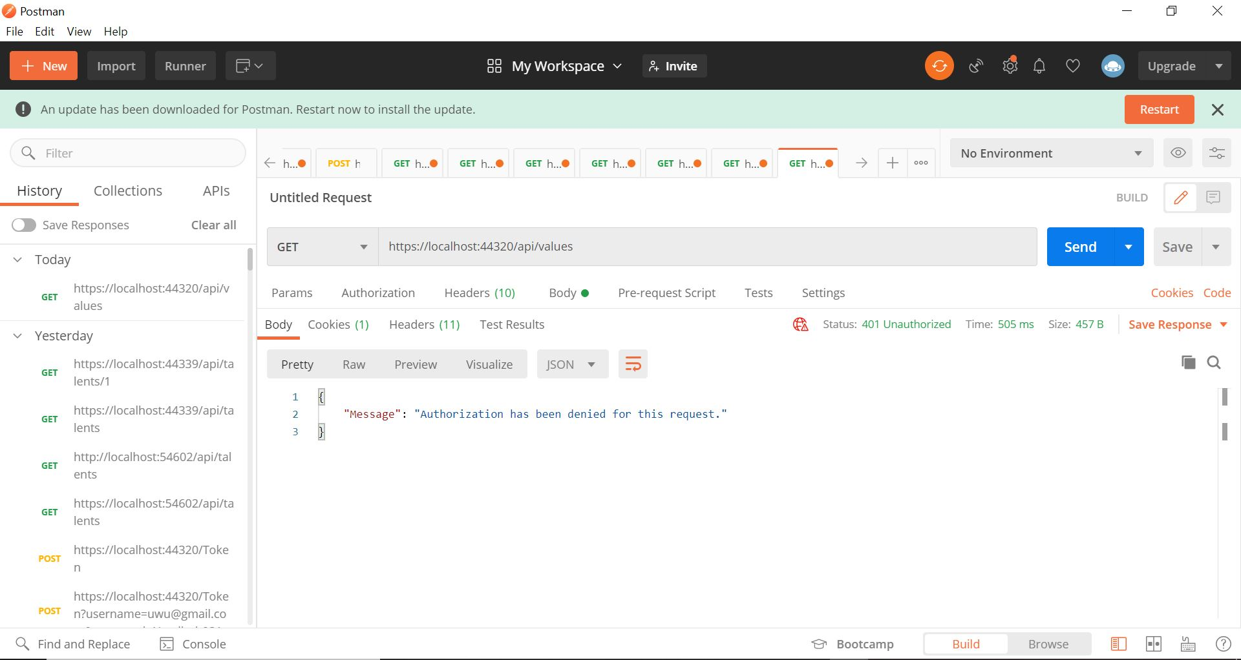

AccountLogout: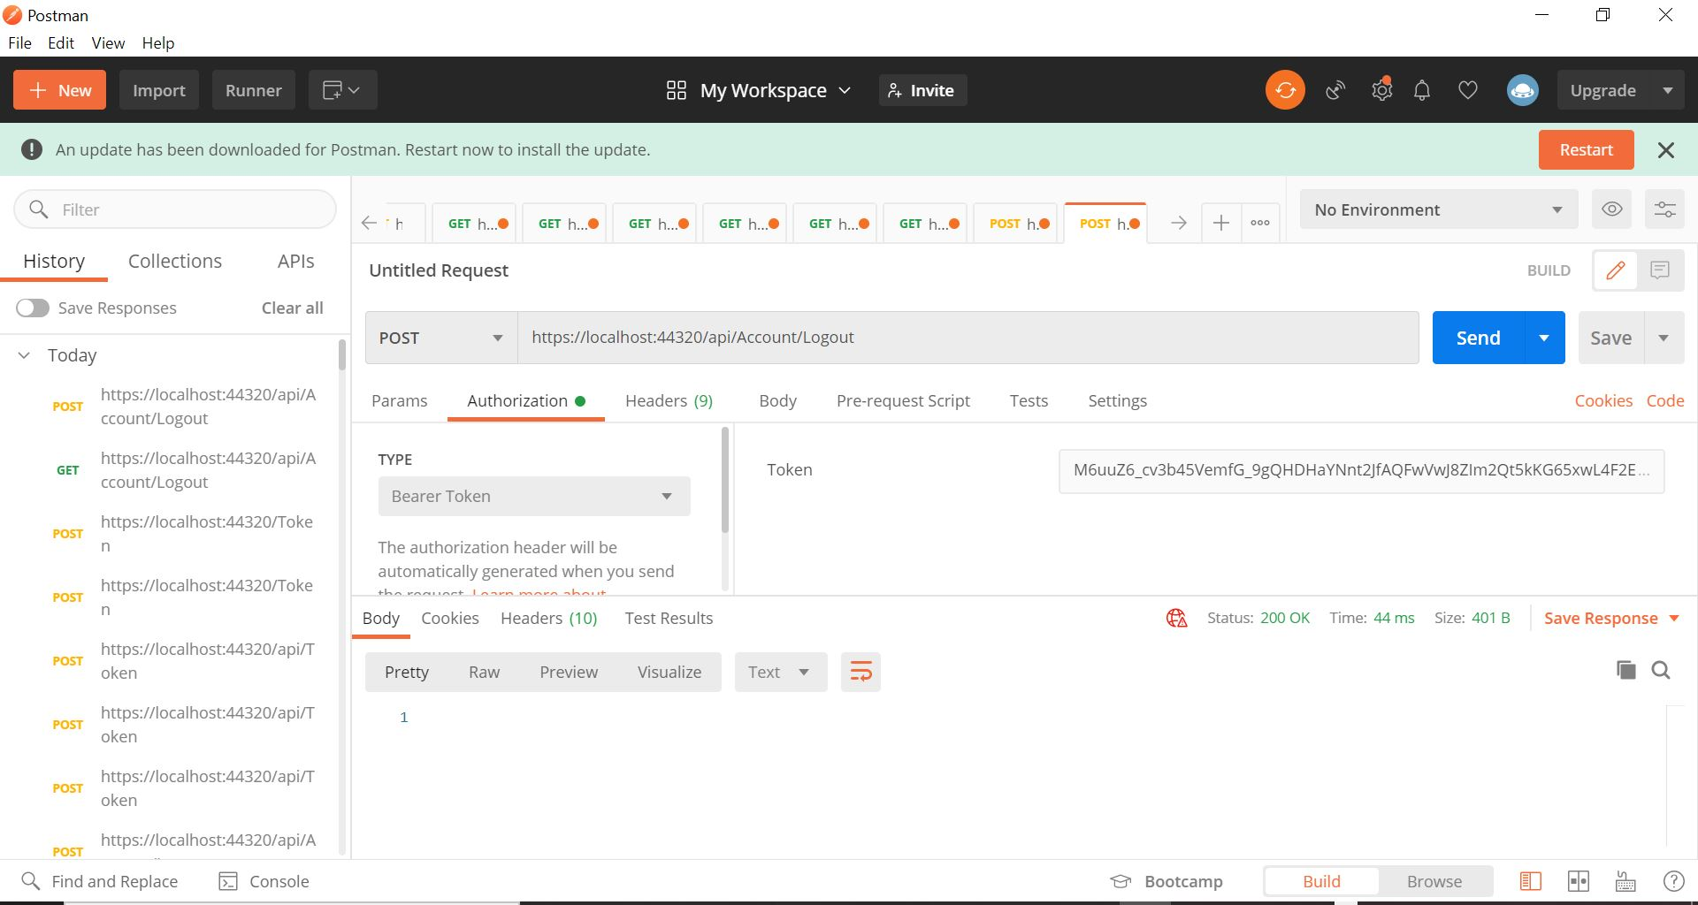

Task4

Web-Api Documentation:

1. Retrieve all talents

METHOD | GET
ROUTE | /api/talents

2. Retrieve talent by id

METHOD | GET
ROUTE | /api/values/{id:INT}

Sequence Diagram:
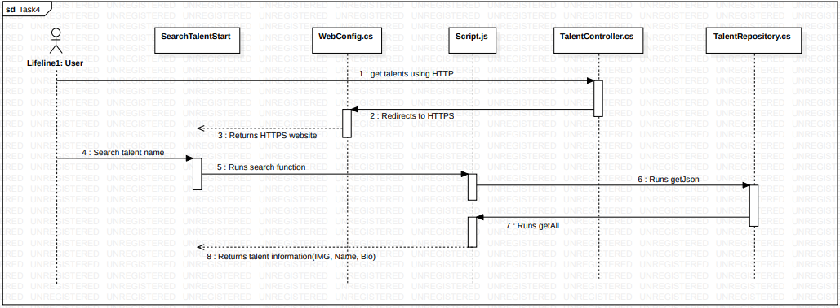

Screenshots:
Get Api/Talents:
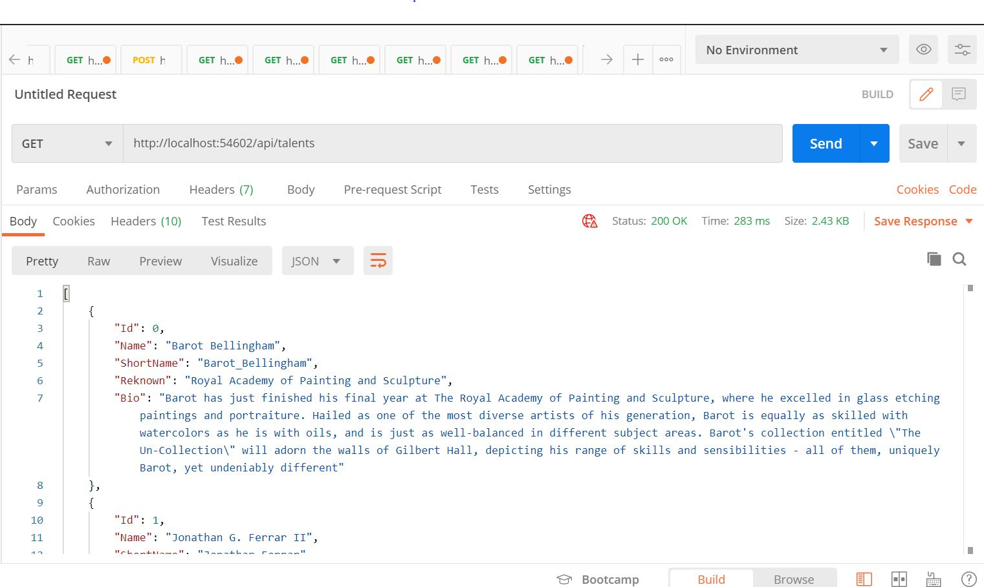
Get Api/Talents/{id}: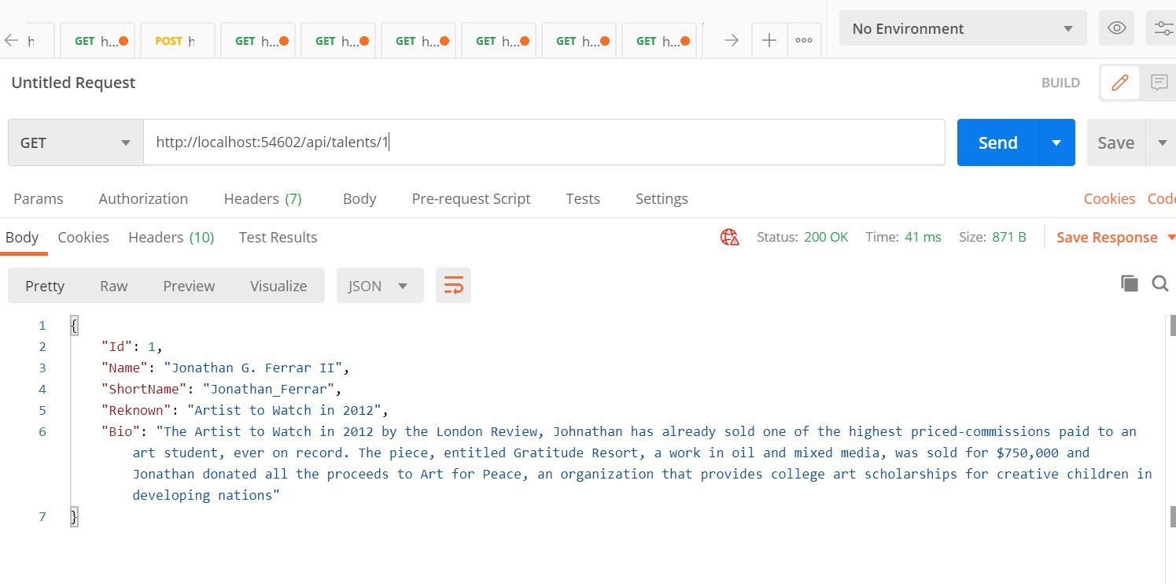
BrowserHTTPS: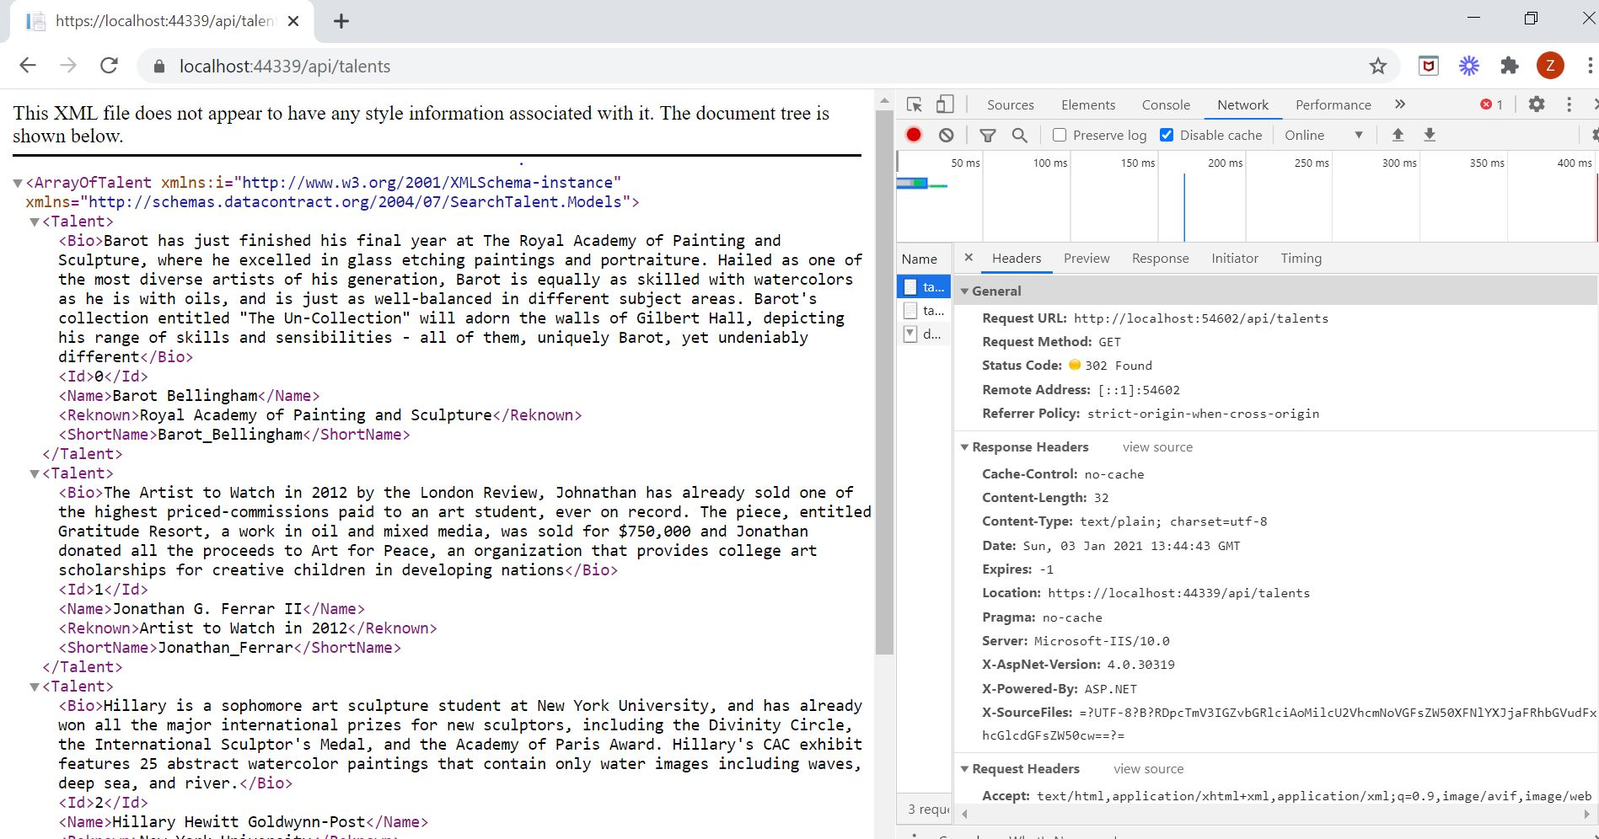

LiveSearch:
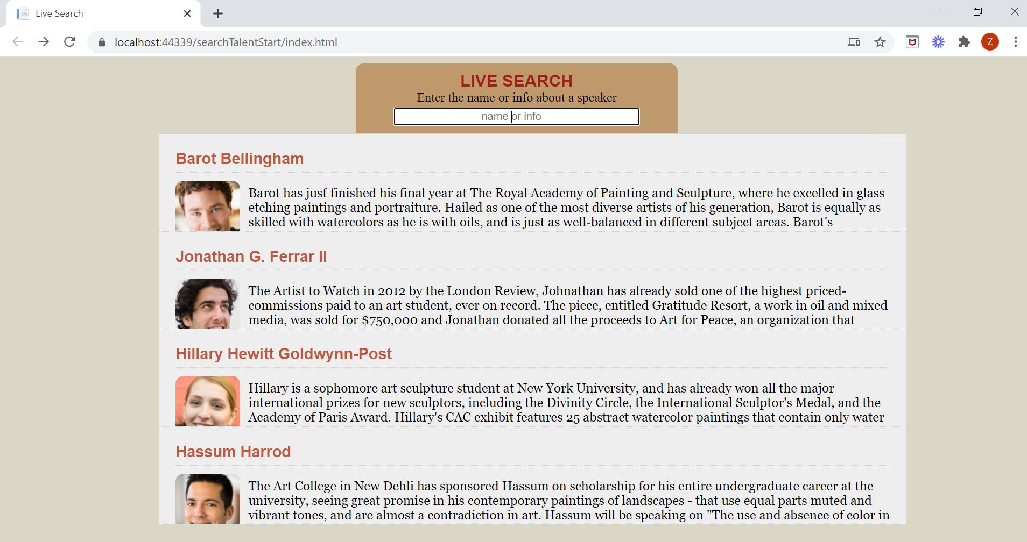

Task5

Web-API Documentation:
- Upload image to S3

METHOD | POST

- Convert long URL to Bit.ly URL

METHOD | POST
ROUTE | https://api-ssl.bitly.com/v4/shorten

Sequence Diagram:
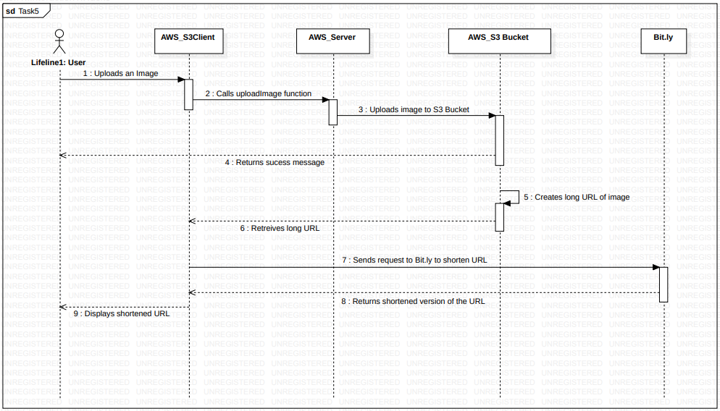

Screenshots:
AWS S3 Bucket:
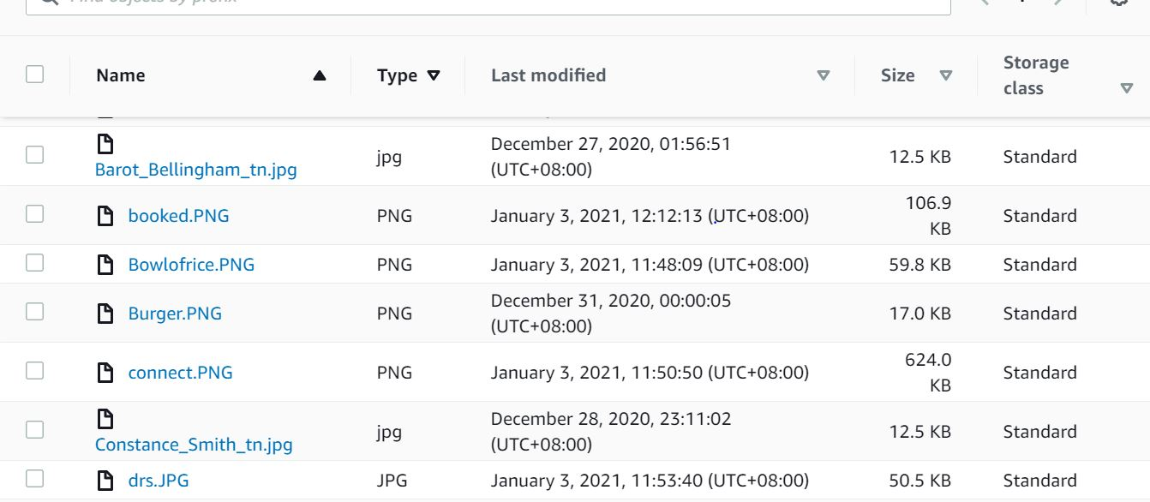

Task6

Web-API Documentation:
1. One time purchase

METHOD | POST
ROUTE | /purchase
PARAMETERS  REQUIRED | ID: Integer, Items: Item Object

2. Create checkout session

METHOD | POST
ROUTE | /create-checkout-session
PARAMETERS  REQUIRED | priceId: String

3. Webhook

METHOD | POST
ROUTE | /webhook
PARAMETERS  REQUIRED | event: String

Sequence Diagram:

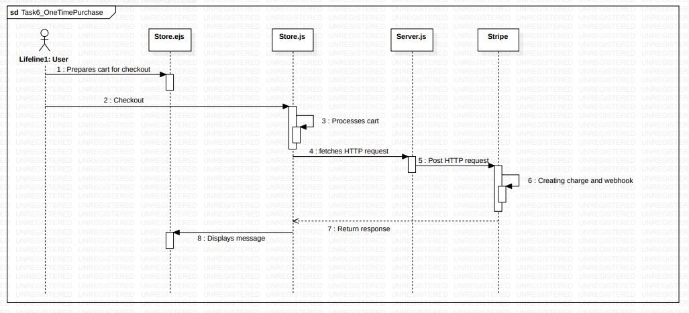

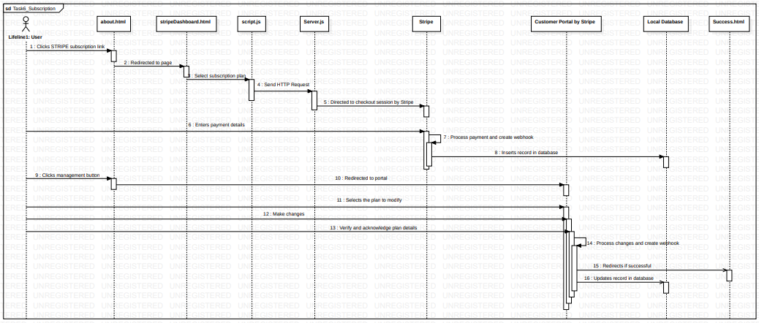

Task7

Sequence Diagram:
